**Task 1: SHaredBike Customer Management System**

**Task 2a: Use-Case Diagram**



**Task 2b: Activity Diagram**



**Task 3a: Class Diagram**

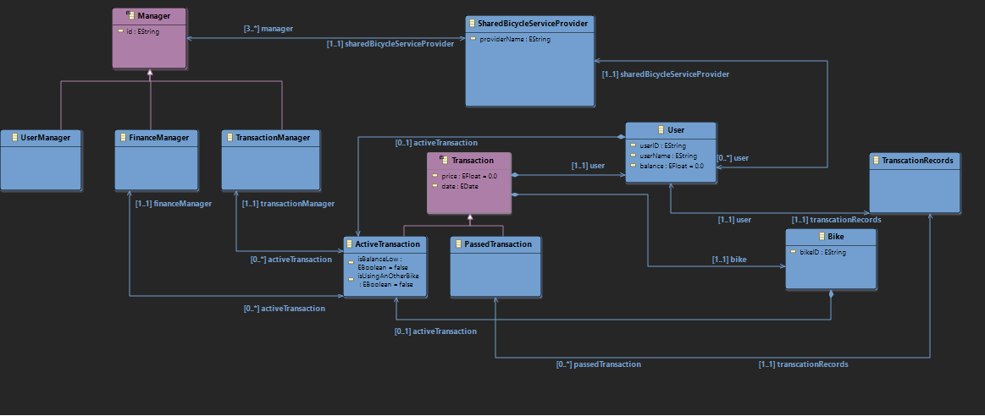

**Task 3b: Business Constraints**